Advanced Features in Spring Framework

ST01: Exploring Lazy & Eager Initialization of Spring Framework Bean

- Eager Initialization - Indicates whether a bean is to be eagerly initialized.
- That means at the moment of object creation, required initialization will be done.
- The Initialization will be done even before the creation/initialization of the context.
- This is the Default Initialization for Spring Beans
- This is the recommended initialization as Errors in the configuration are discovered immediately at application startup.

In the below example, the Constructor of ClassB/Bean is getting initialized at the time of object creation & that’s why in the response, we can see the first message which is getting printed is “Initialization completed !” & then the context is created & initialized.
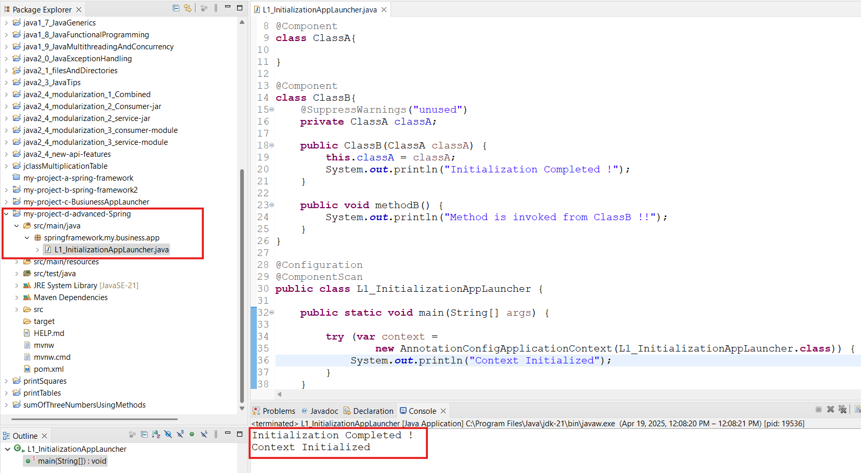

- Lazy Initialization - Indicates whether a bean is to be eagerly initialized.
- That means the required initialization will not be done at the time of object creation.
- The Initialization will be done when any of the methods is getting invoked from the class or the class is accessed for the very first time.
- A class can be declared as Lazily initialized by using @Lazy Annotation.
- This annotation can be used everywhere @Component & @Bean is used.
- Lazy - resolution proxy will be injected instead of actual dependency
- It can be used on Configuration Class but it will make all the Bean methods Lazily Initialized.

In the below example, we can see that in the response the context Initialization is done first & then when we are trying to access the ClassB, the Constructor initialization happens.
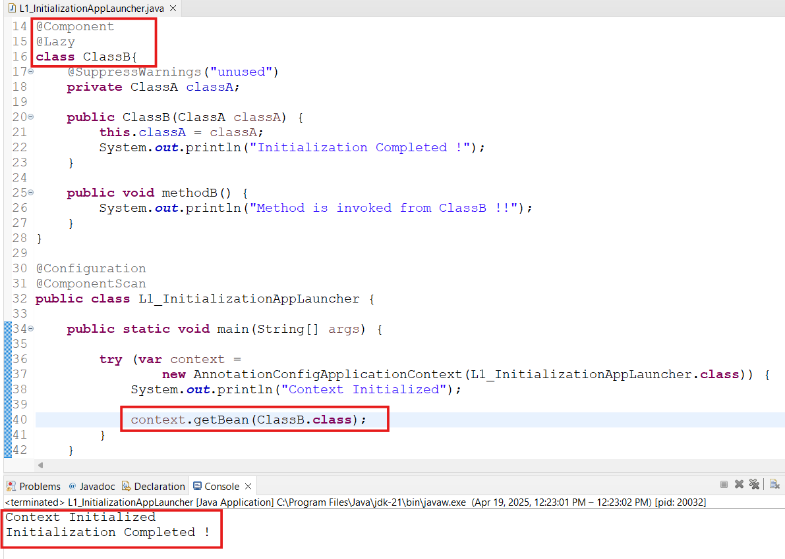

ST02: Comparing Lazy initialization vs Eager Initialization

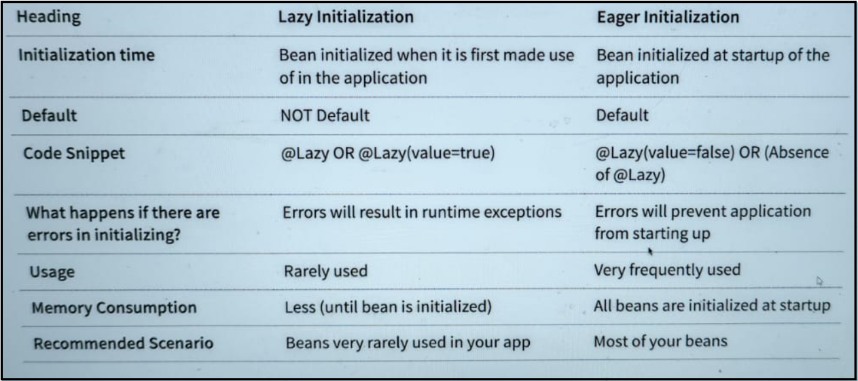

ST03: Exploring Java Spring Framework Bean Scope - Prototype & Singleton

Singleton Bean Scope
- Under this scope, the same Bean object/instance is returned each time when the Bean is called or the same Bean instance is reused.
- This is the default Bean Scope(if explicit scope is not provided Singleton Bean will be effective)
- It can also be configured by using Annotation - ‘Scope(value=ConfigurableBeanFactory.SCOPE_SINGLETON)’
- This is used very frequently as the stateless Beans(A single Bean per IOC Container)

Prototype Bean Scope
- Under this scope, a new Bean object/instance is returned each time when the Bean is called or the new Bean instance is created & returned/retrieved.
- It can be configured by using Annotation - ‘Scope(value=ConfigurableBeanFactory.SCOPE_PROTOTYPE)’
- This is rarely used & for the stateful Beans(Possibly several Beans per IOC Container)

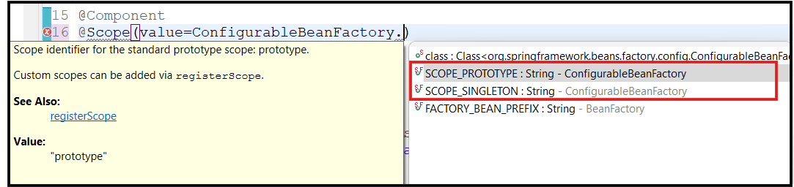

Let’s create a Launcher app by using Singleton & Prototype Bean scope.

- NormalClass
- No explicit scope is defined, therefore this will be considered under SINGLETON Bean scope.
- This will create only one Bean per IOC container & each time the same Bean will be returned when the Bean will be invoked.

- PrototypeClass
- An explicit scope is defined for the PROTOTYPE scope.
- This will create several Beans per IOC container & different Beans will be returned on each invocation.

- SpringBeanScopeLauncher
- Application Context will be created & initialized in this class.
- Singleton(Normal) class will be invoked multiple times.
  - Each time same Bean instance will be returned
- Prototype class will be invoked several times.
  - Each time a new Bean instance will be returned
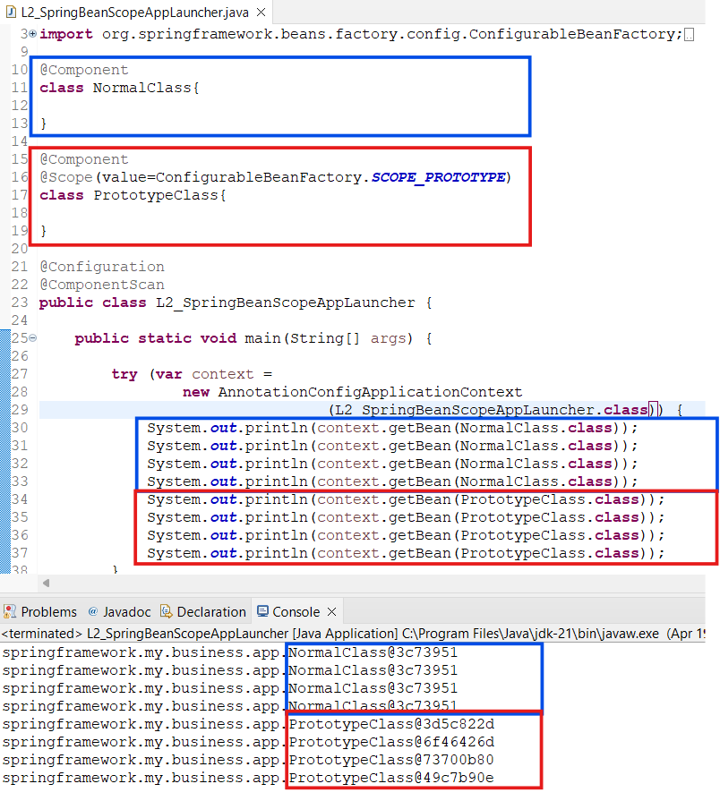

Output - We can see that for Singleton/Normal class/Bean the Hashcode is exactly the same. That means the exact same Bean is retrieved.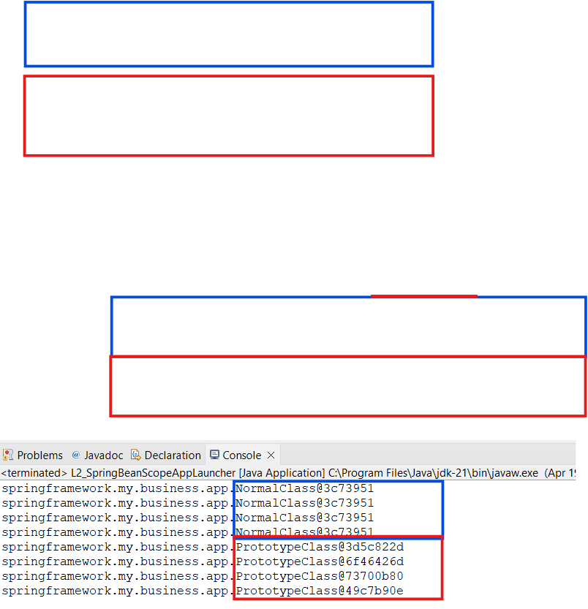

Apart from the Singleton or Prototype Scopes, there are some more Beans which are specific to the Web Applications:
- Request Scope - One object instance per single HTTP request
- Session Scope
- One object instance per user HTTP request
- A session is typically associated with a user.
- Multiple requests belonging to the same user might be belonging to the same session.

- Application Scope - One object instance per Web Application runtime.
- Websocket Scope - One object instance per Websocket instance

Java Singleton(GOF) vs Spring Singleton:

- Singleton is a creational design pattern, which ensures that only one object of its kind exists and provides a single point of access to it for any other code

- Java Singleton(GOF) - One object instance per JVM

Consider that there are multiple Spring IOC Containers running per JVM, then the Java Singleton(GOF) & Spring Singleton will have different meanings but otherwise both can be considered as similar.

ST04: Comparing Prototype & Singleton Spring Frameworks Bean Scopes

Prototype & Singleton Bean Scope
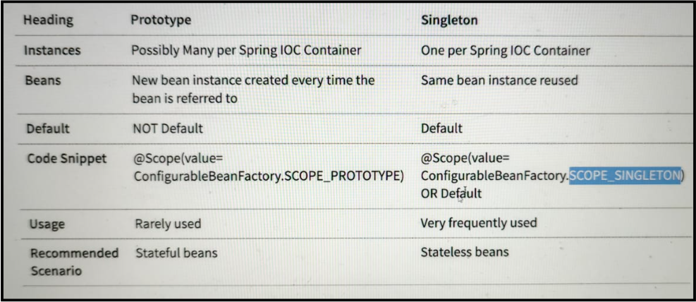
Stateful Beans - The Beans which have sensitive information like user data, then ProtoType Scope is used to create multiple instances of the bean for the different users.

Stateless Beans - The Beans which are Generic in nature & can be used throughout the application
ST05: Exploring Spring Beans - PostConstruct & PreDestroy

PostConstruct
As soon as the Bean is created & construction initialization is done, the methods Annotated as ‘@PostConstruct’ will be called automatically to get the necessary custom initialization done.
For Example - Establishing DB connection, looking for the required resources availability etc.

PreDestroy
As soon as the Bean is about to be destroyed by the JVM , the methods Annotated as ‘@PreDestroy’ will be called automatically to get the necessary cleanup activity done.
For Example - Closing the DB connection, releasing the necessary resources.

Example : lets create an example & see how it works

MainClass : This is the class where the Dependencies will be resolved under a Constructor.
This will have below Methods:

- initialize() - This method is Annotated as ‘@PostConstruct’.
That means this will be called automatically as soon as the Bean is created.
This will call another ‘getReady()’ method present in the DependencyClass.

- cleanup() - This method is Annotated as ‘@PreDestroy’.
That means this will be called just before the Bean destruction.
This will call another ‘cleanup()’ method present in the DependencyClass for cleanup.

DependencyClass : This is the Dependency class where the

This will have below Methods:

- getReady() - The required initialization will be done here.
- cleanup() - The required cleanup will be done here.

PostConstructAndPreDestroyAppLauncher : This is the Runner/Launcher class.

package springframework.my.business.app;

import org.springframework.context.annotation.AnnotationConfigApplicationContext;
import org.springframework.context.annotation.ComponentScan;
import org.springframework.context.annotation.Configuration;
import org.springframework.stereotype.Component;
import jakarta.annotation.PostConstruct;
import jakarta.annotation.PreDestroy;

@Component
class MainClass{

private DependencyClass dependencyClass;
public MainClass(DependencyClass dependencyClass) {
super();
this.dependencyClass = dependencyClass;
System.out.println("All the Dependencies are ready..");
}

@PostConstruct
public void initialize() {

dependencyClass.getReady();

}

@PreDestroy
public void cleanup() {
dependencyClass.cleanup();
}

}

@Component
class DependencyClass{

public void getReady() {
System.out.println(
"""
==> The required initialization is being done post Bean
creation & initialization
==> -- DB connected successfully
==> -- All the files are available & opened for access.
==> Initialization Completed !!
""" );

}

public void cleanup() {

System.out.println(
"""
==> The resource cleanup is being done prior to the Bean
destruction.
==> -- DB connection closed.
==> -- All the files have been closed.
==> The Resource cleanup Completed !!
""" );

}
}

@Configuration
@ComponentScan
public class L3_PostConstructAndPreDestroyAppLauncher {
public static void main(String[] args) {
try (var context =
new AnnotationConfigApplicationContext
(L3_PostConstructAndPreDestroyAppLauncher.class)) {

System.out.println(context.getBean(MainClass.class));
}

}

}

Output:
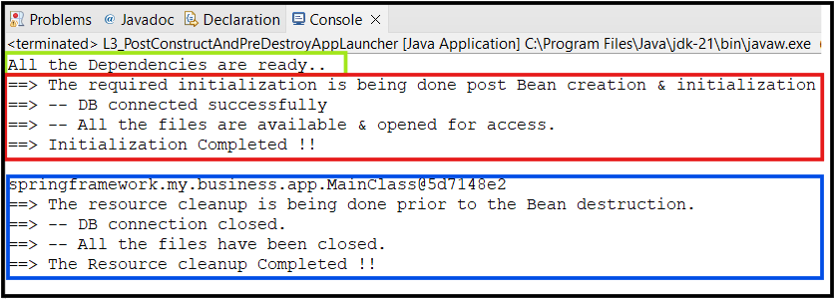

We can see that, when the getBean method is invoked to get the Bean for MainClass, the method(s) performing required initialization have been triggered automatically (no explicit call is made to invoke method(s).

First constructor initialization is done then method with Annotation is invoked.

And Finally before the Bean destruction, cleanup() method is invoked by Spring.

ST06: Evolution of Jakarta EE - Comparing with J2EE & Java EE

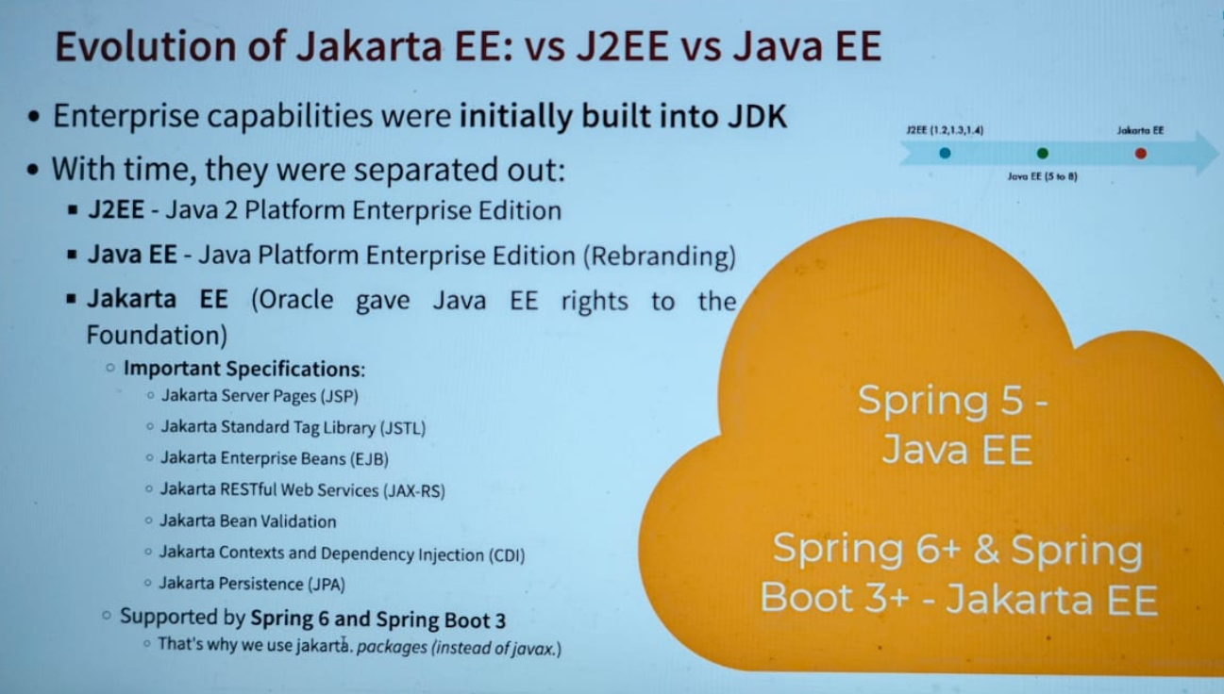

ST07: Exploring Jakarta CDI with Spring Framework & Java

CDI Specification:
- CDI stands for Contexts & Dependency Injection.
- This is a specification which is a part of Jakarta EE & Spring Framework supports this.
- CDI Specifications was introduced into Java EE 6 platform in December 2019.
- This is now called as Jakarta Contexts & Dependency Injection(CDI)
- Since this is a specification, that means this is an Interface & there are no implementations present in it.
- Spring Framework provides implementation for the CDI
- As part of CDI, there are a few important API ANnotations present
  - Important inject API Annotations
    - Inject (~Autowired in Spring)
Inject is very very similar to Autowired.
    - Named (~Component in Spring)
Named is very very similar to Component
    - Qualifier
    - Scope
    - Singleton

- Let's make a use of CDI through an example

To use CDI, we need to add a Dependency to the pom.xml file
Under the Spring boot started add a dependency as follows: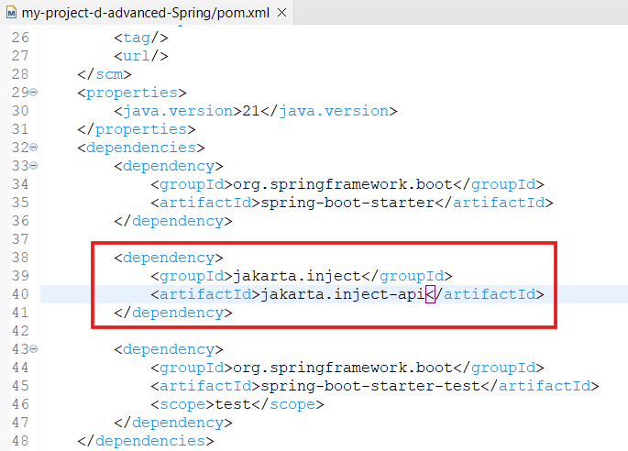

Now first have a look into Component & Autowired

package springframework.b.JakartaCDI;
import java.util.Arrays;
import org.springframework.beans.factory.annotation.Autowired;
import org.springframework.context.annotation.AnnotationConfigApplicationContext;
import org.springframework.context.annotation.ComponentScan;
import org.springframework.context.annotation.Configuration;
import org.springframework.stereotype.Component;

@Component
class BusinessService{

private DataService dataService;

@Autowired
public void setDataService(DataService dataService) {
System.out.println("Setter Injection done..");
this.dataService = dataService;
}

public DataService getDataService() {
return dataService;
}
}

@Component
class DataService{
}

@Configuration
@ComponentScan
public class WithoutJakartaCDIContextAppLauncher {
public static void main(String[] args) {
try (var context =
new AnnotationConfigApplicationContext
(CDIContextAppLauncher.class)) {

Arrays.stream(context.getBeanDefinitionNames())
.forEach(System.out::println);

System.out.println(context.getBean(BusinessService.class)
.getDataService());

}
}
}

Output
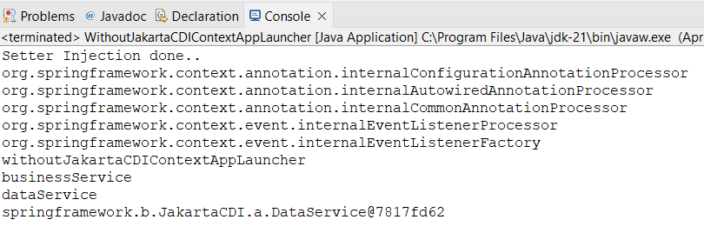

We can see the first Setter Injection is done & it listed all the available Bean.

Now let’s use CDI ANnotations instead of Spring Annotations.

package springframework.b.JakartaCDI.b;
import java.util.Arrays;
import org.springframework.context.annotation.AnnotationConfigApplicationContext;
import org.springframework.context.annotation.ComponentScan;
import org.springframework.context.annotation.Configuration;
import jakarta.inject.Inject;
import jakarta.inject.Named;

@Named
class BusinessServiceA{

private DataServiceA dataServiceA;

@Inject
public void setDataService(DataServiceA dataServiceA) {
System.out.println("Setter Injection done..");
this.dataServiceA = dataServiceA;
}
public DataServiceA getDataServiceA() {
return dataServiceA;
}
}

@Named
class DataServiceA{
}

@Configuration
@ComponentScan
public class WithJakartaCDIContextAppLauncher {
public static void main(String[] args) {
try (var context =
new AnnotationConfigApplicationContext
(WithJakartaCDIContextAppLauncher.class)) {

Arrays.stream(context.getBeanDefinitionNames())
.forEach(System.out::println);

System.out.println(context.getBean(BusinessServiceA.class
).getDataServiceA());

}
}
}

Output: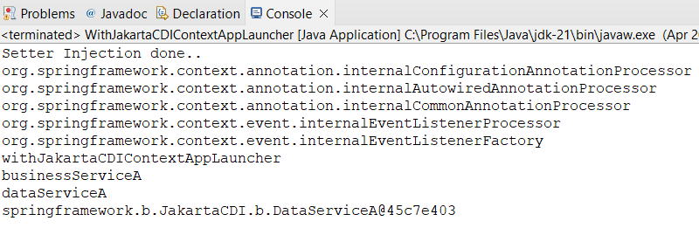

Looking into the responses, it is clear that are @Named & @Inject are the alternatives to the @Component & @Autowired

ST08: Exploring Java Spring XML Configuration

Till now whatever we have seen regarding the Bean creation & Dependency Injection or Autowiring. These are the latest features available in the Spring Framework where we used to create a configuration class file & manage Beans in it.

But in the olden days, developers used to create the Beans by managing a XML Configuration file.

Let’s create/update the Gaming Application by managing Beans through a XML Config file
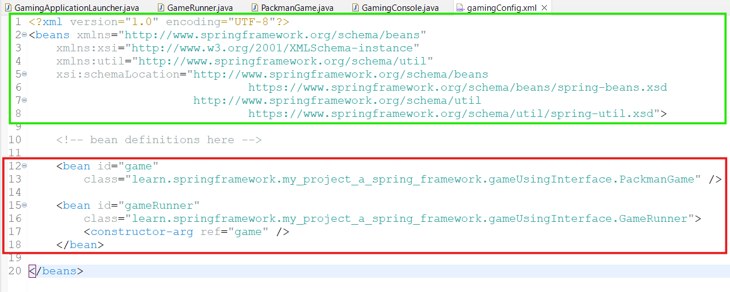

The util Schema
As the name implies, the util tags deal with common, utility configuration issues, such as configuring collections, referencing constants, and so forth.

To use the tags in the util schema, we need to have the following preamble at the top of the Spring XML configuration file :

<?xml version="1.0" encoding="UTF-8"?>
<beans xmlns="http://www.springframework.org/schema/beans"
xmlns:xsi="http://www.w3.org/2001/XMLSchema-instance"
xmlns:util="http://www.springframework.org/schema/util"

xsi:schemaLocation="
http://www.springframework.org/schema/beans
https://www.springframework.org/schema/beans/spring-beans.xsd

http://www.springframework.org/schema/util
https://www.springframework.org/schema/util/spring-util.xsd">

<!-- bean definitions here -->

</beans>

Now, below the commented line , we can start creating Bean Configuration data

- Creating Game specific Bean (Ex: for PackmanGame class)

Here we need to define the parameter - id(Bean will be identified with this name or it’s an instance of the class) & class (class of which Bean needs to be created - package.ClassName)

<bean id="game"
class="learn.springframework.my_project_a_spring_framework.gameUsingInterface.PackmanGame" />

- Creating Bean for GameRunner class

Since this is a GameRunner class, we need to pass the constructor argument as well.

<bean id="gameRunner"
class="learn.springframework.my_project_a_spring_framework.gameUsingInterface.GameRunner">

<constructor-arg ref="game" />

</bean>

In this way the Bean for the GameRunner class will be created along with the constructor initialization.

Now we do not need to add Annotations(@Component or @Bean or @Qualifier) in the PackmanGame or in the GameRunner class to create the beans. It will become a normal class without Bean specific Annotations.

PackmanGame class: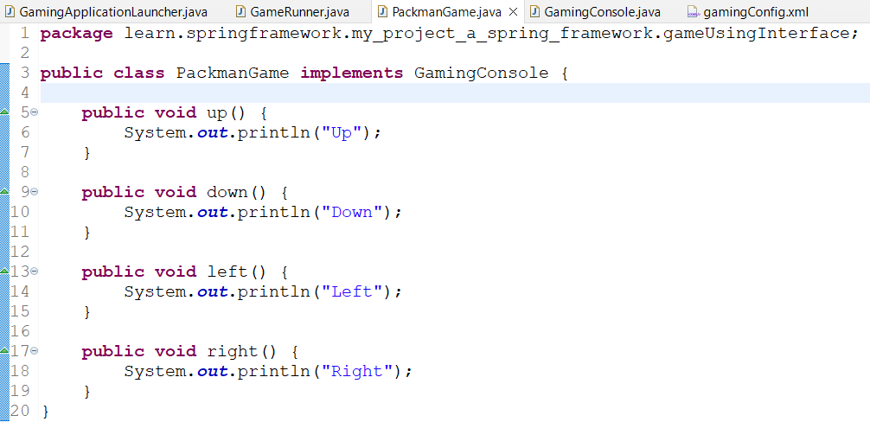

GameRunner class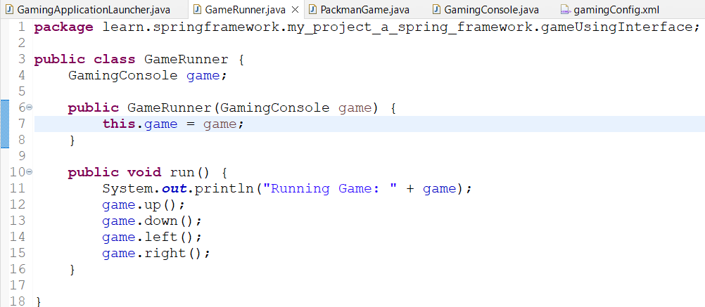

Now we are good to update the Game Launcher class to define the context by using the proper Application COntext required for XML configuration.

GamingApplicationLauncher class
We need to create context using ClassPathXMLApplicationContext & pass the path to the XML file.
Here only config file name is suffice as the class path already have the path of current source.
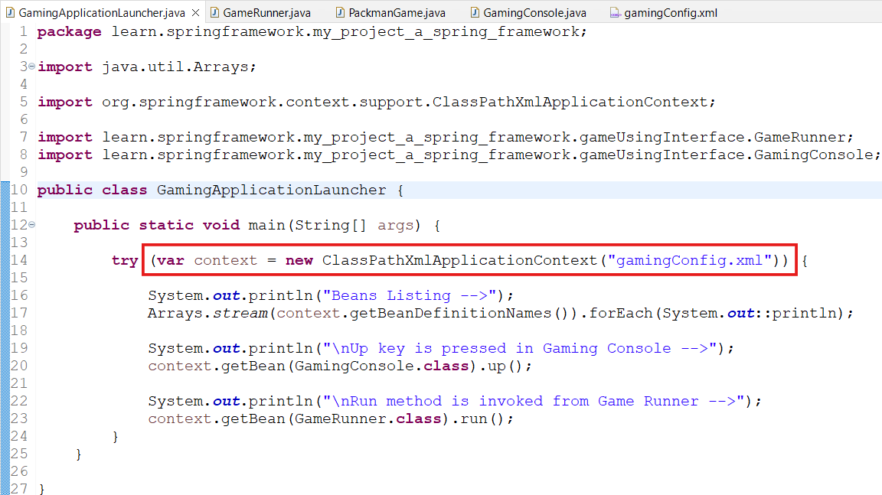

Now run the application & see the result.

Output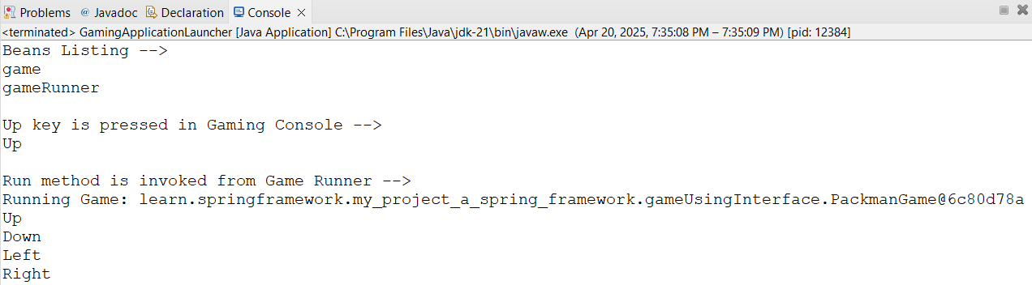

ST09: Java Annotations vs XML Configuration

Heading | Annotations | XML Configuration
Ease Of Use | Very Easy (defined close to source like class, method and/or variable) | Cumbersome
Short & Concise | Yes | No
Clean POJOs | No  POJOs are polluted with Spring Annotations | Yes  No change in Java code.
Easy to Maintain | Yes | No
Usage Frequency | Almost all recent projects | Rarely
Recommended | Either of them is fine BUT be consistent & Do NOT mix both
Debugging Level | Hard | Medium

ST10: Exploring Spring framework - Stereotype Annotations

There are a number of Stereotype Annotations present in the SPring Framework that can be used to create & manage Beans:
- @Component - This is a generic Annotation applicable for any/all classes.

A bean can be created for any class as this is a base for all Spring Stereotype Annotations

Below are the Specializations of @Component Annotations that can be used for specific purposes instead of using @Component.

- @Service - In case any class has Business Logic, then this can be used instead of Component Annotation.

- @Controller - This is used to define controllers in the Web Applications & Rest APIs. This indicates that the annotated class is a controller.

- @Repository - In case any class is used to communicate the Database (Retrieve or Manipulate the data), then this can be used instead of Component Annotation.

Recommendation: Always use the most specific Annotation

Why:
- By using the most specific Annotation, we are providing more information to the Spring framework about our intentions.
- We can also use AOP(Aspect Oriented Programming) to detect the Annotation & add additional behaviour
ST11: Quick Review of Important Spring Annotations

Annotation | Description
@Configuration | Indicates that a class declares one or more @Bean methods and may be processed by the Spring container to generate bean definitions.
@ComponentScan | Define specific packages to scan for components. If specific packages are not defined, scanning will occur from the package of the class that declares this annotation
@Bean | Indicates that a method produces a bean to be managed by the Spring container
@Component | Indicates that an annotated class is a "component" & a Bean can be created for it.
@Service | Specialization of @Component indicating that an annotated class has business logic.
@Controller | Specialization of @Component indicating that an annotated class is a "Controller" (e.g. a web controller).  Used to define controllers in your web applications and REST API
@Repository | Specialization of @Component indicating that an annotated class is used to retrieve and/or manipulate data in a database
@Primary | Indicates that a bean should be given preference when multiple candidates are qualified to autowire a single - valued dependency.
@Qualifier | Used on a field or parameter as a qualifier for candidate beans when autowiring. It has a precedence over @Primary Annotation.
@Lazy | Indicates that a bean has to be lazily initialized.  Absence of @Lazy annotation will lead to eager initialization
@Scope | @Scope(value=ConfigurableBeanFactory.SCOPE_PROTOTYPE)  Defines a bean to be a prototype - a new instance will be created every time you refer to the bean.  Default scope is singleton - one instance per IOC container.
@PreDestroy | Identifies the method that will receive the callback notification to signal that the instance is in the process of being removed by the container.  Typically used to release resources that it has been holding.
@Named | Jakarta Contexts & Dependency Injection (CDI) Annotation similar to Component
@Inject | Jakarta Contexts & Dependency Injection (CDI) Annotation similar to Autowired
@PostConstruct | Identifies the method that will be executed after dependency injection is done to perform any initialization
ST12: Quick Review of Important Spring Concepts

Concept | Description
Dependency Injection | Identify beans, their dependencies and wire them together (provides IOC - Inversion of Control)
Constr. injection | Dependencies are set by creating the Bean using its Constructor
Setter injection | Dependencies are set by calling setter methods on your beans
Field injection | No setter or constructor. Dependency is injected using reflection.
IOC Container | Spring IOC Context that manages Spring beans & their lifecycle
Bean Factory | Basic Spring IOC Container
Application Context | Advanced Spring IOC Container with enterprise-specific features - Easy to use in web applications with internationalization features and good integration with Spring AOP
Spring Beans | Objects managed by Spring
Auto-wiring | Process of wiring in dependencies for a Spring Bean

ST13:

